**Time-triggered lambda code**

Cody wants to be able to pull a full report of all speeders, forever, for all time - and she wants it updated nightly.

She asked you to create a nightly job

The current structure looks like this: 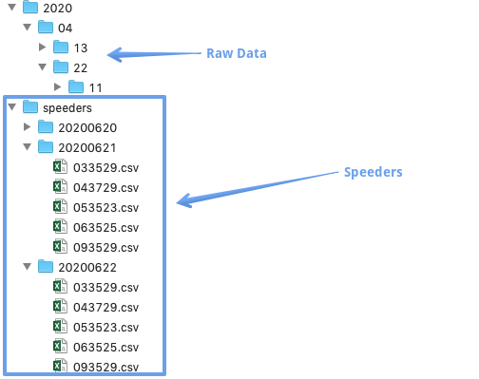

Write the code that would go into the lambda_handler method of the function you created in the last exercise.

All boto3, pandas and awsrangler have been imported for you, and the keys have been defined.

Let's roll!

**Instructions**

**100 XP**

* Initialize the boto3 session with AWS_KEY_ID and AWS_SECRET.
* Pass the session to the AWS Wrangler read_csv method to get all the speeder dataframes.
* Use AWS Wrangler to write the resulting csv with the key "sd-vehicle-data/speeders-full/full.csv".

Code:

# Initialize boto3 session

session = boto3.Session(aws_access_key_id = AWS_KEY_ID,

                     aws_secret_access_key = AWS_SECRET,

                     region_name="us-east-1")

# Read all records in the speeders folder

speeders_total = wr.s3.read_csv('s3://sd-vehicle-data/speeders',

                                boto3_session = session,

                                delimiter=" ")

# Write aggregated speeders file

wr.s3.to_csv(df = speeders_total,

             boto3_session=session,

             path="s3://sd-vehicle-data/speeders-full/full.csv")